- \Operation\Product hoppers\Product hoppers
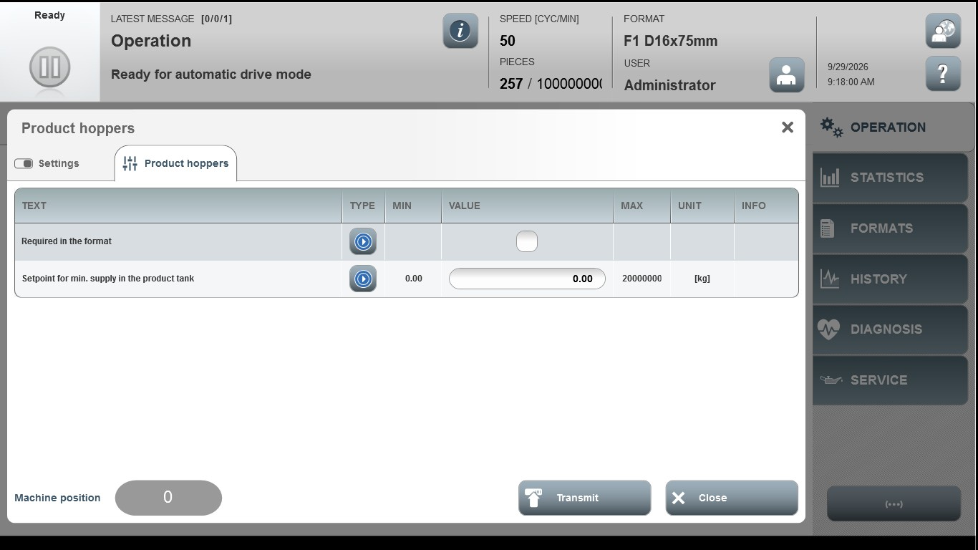
Acceptance criterion | Limits | Pass / Fail: Dev-No. | Date | Initials
Screen matches screenshot | N / A
Set point for min. supply in the product tank | 0.00 … 20000000

